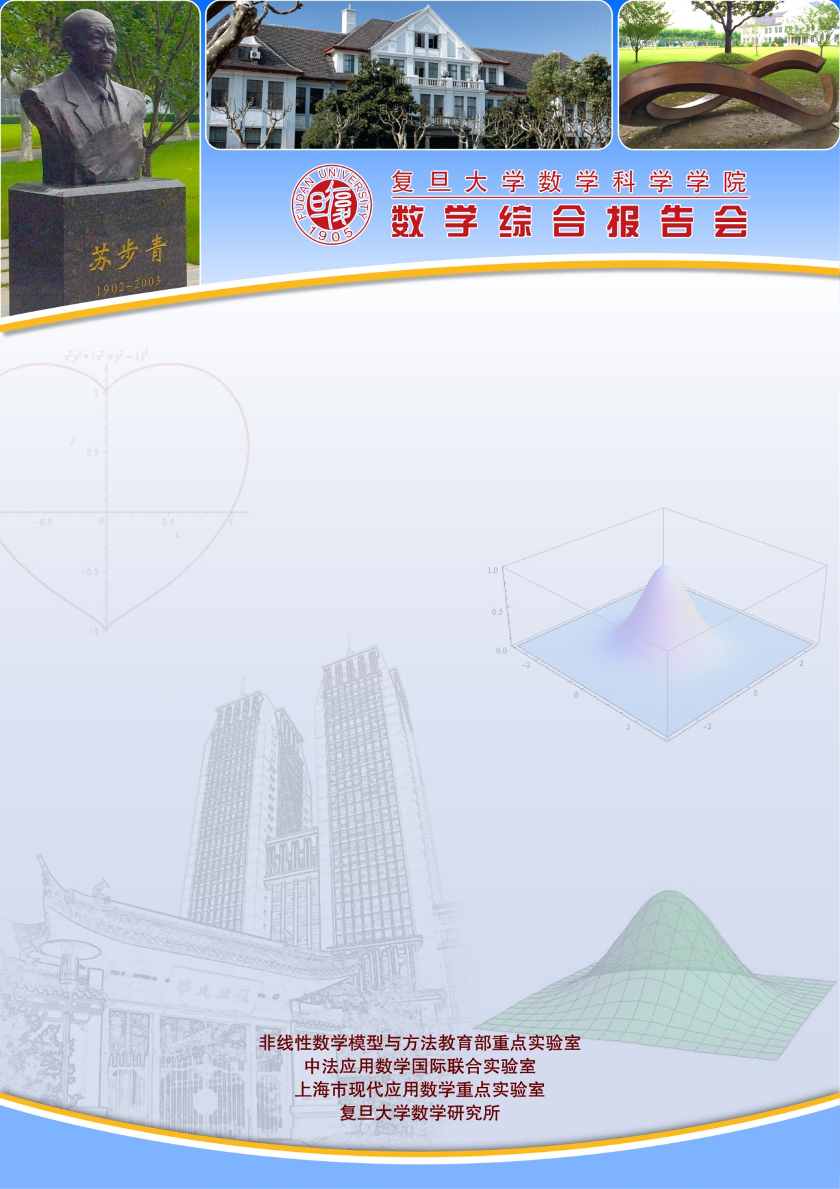
报告题目：Simplest bifurcation diagrams for families of vector fields on a torus
报告人：Prof Claude Baesens
（Mathematics Institute, University of Warwic）
时间：2017-08-08 星期二9:30-10:30
地点：光华东主楼2001
摘要：We prove that the bifurcation diagram for a monotone two-parameter family of vector fields on a torus has to be at least as complicated as the conjectured simplest one proposed in [BGKM]. To achieve this we define ``simplest'' by minimis-ing sequentially the numbers of equilibria, Bogdanov-Takens points, closed curves of centre and of neutral saddle, intersections of curves of centre and neutral saddle, Reeb components, other invariant annuli, arcs of rotational homoclinic bifurcation of hori-zontal homotopy type, necklace points, contractible periodic orbits, points of neutral horizontal homoclinic bifurcation and half-plane fan points. We obtain two types of simplest case, including that initially proposed. [BM1] We analyse the bifurcation diagram of the explicit monotone family $\dot{x} = \Omega_x - \cos{2\pi y} - \eps \cos{2\pi x$, $\dot{y} = \Omega_y - \sin{2\pi y} - \eps \sin{2\pi x$ and prove it satisfies all the assumptions on simplest bifurcation diagram except the one of at most one contractible periodic orbit. Indeed we find that it has four points of degenerate Hopf bifurcation [BM2]
References:
[BGKM] C Baesens, J Guckenheimer, S Kim, RS MacKay,Three coupled oscillators: mode-locking, global bifurcations and toroidal chaos, Physica D 49 (1991) 387-475.
[BM1] C Baesens and RS MacKay, Simplest bifurcation diagrams for monotone families of vector fields on a torus
[BM2] C Baesens and RS MacKay, An almost simplest monotone family of vector fields on a torus

