2025环面拓扑研讨会
（2025-11-28~2025-12-01）
Workshop on TORIC TOPOLOGY 2025
（November 28-December 1, 2025）

School of Mathematical Sciences
Fudan University

SCHEDULE
November 28, 2025
09:30-18:00 | Arrival and Registration

November 29, 2025
9:10-9:30 | Opening and Photos
9:30-10:15 | Mikiya Masuda |  | Chair: Ping Li
10:15-10:30 | Break
10:30-11:15 | Bin Zhang |  | Chair: Ping Li
11:15-11:30 | Break
11:30-12:15 | Bernardo Uribe | Chair: Ping Li
12:15-14:00 | Lunch
14:00-14:45 | Hideya Kuwata | Chair: Takashi Sato
14:45-15:00 | Break
15:00-15:45 | Li Yu | Chair: Takashi Sato
15:45-16:00 | Break
16:00-17:30 | Open Problems

November 30, 2025
09:30-10:15 | Qiangbo Tan | Chair: Li Cai
10:15-10:30 | Break
10:30-11:15 | Shintaro Kuroki | Chair: Li Cai
11:15-11:30 | Break
11:30-12:15 | Bo Chen | Chair: Li Cai
12:15-14:00 | Lunch
14:00-14:45 | Takashi Sato | Chair: Wei Wang
14:45-15:00 | Break
15:00-15:45 | Yuanxin Guan | Chair: Wei Wang
15:45-16:00 | Break
16:00-17:30 | Open Problems

December 1, 2025
09:30-18:00 | Departure

VENUE
The talks are all presented in Room 1801, Guanghua Eastern Main Tower, Fudan University (Handan Campus).

Organizing Committee:
Shintaro Kuroki (Okayama University of Science)
Hao Li (University of Shanghai for Science and Technology)
Ping Li (Fudan University)
Zhi Lü (Fudan University)
Wei Wang (Shanghai Ocean University)
Haozhi Zeng (Huazhong University of Science and Technology)

OTHER USEFUL INFORMATION
ACCOMMODATION
Qingyun Hotel (No.220 Handan Road, Yangpu District, Shanghai).
卿云宾馆，地址：上海市杨浦区邯郸路220号。

HOW TO REACH THE VENUE (6 min walk)

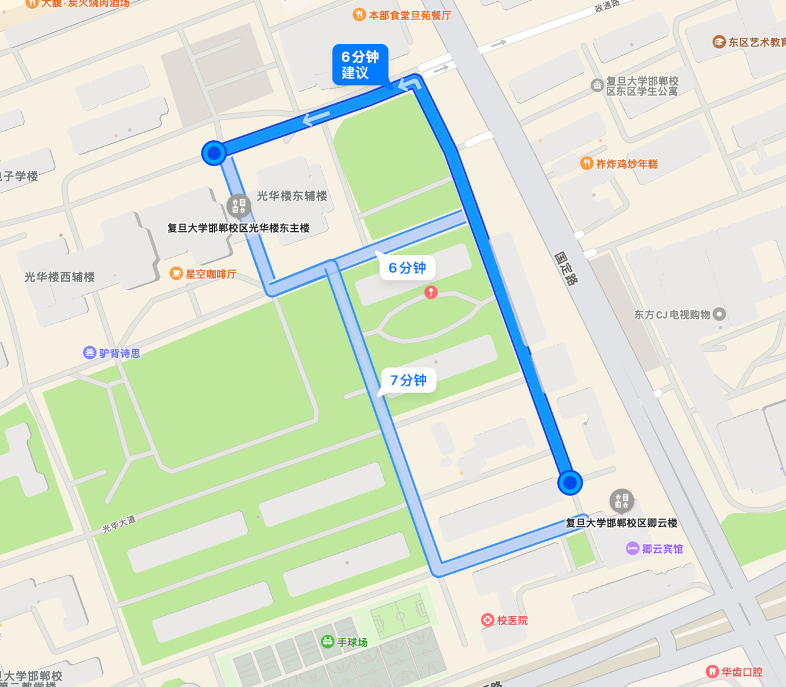
Guanghua Easter Main Tower
Qingyun Hotel

