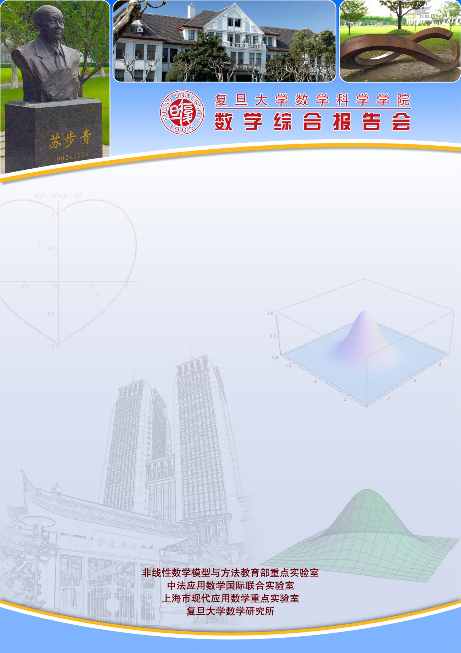
报告题目：Some recent results on fully nonlinear elliptic equations with gradient terms on complex manifolds
报告人：关波 教授
（Ohio State University, Xiamen University）
时间：2017-08-01 星期二10：00-11：00
地点：光华东主楼2001
摘要：We consider fully nonlinear elliptic equations on complex manifolds, some of which arise from complex geometry. We are concerned with deriving a priori estimates for such equations and present recent results on a special class of equations which involve gradient terms. The talk is based on joint work with Xiaolan Nie, Chunhui Qiu and Rirong Ruan. We shall also clarify the relations between recently introduced notions of generalized subsolutions.

